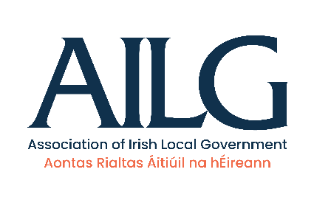
Short biographies:
AILG Key Personnel
Cllr. Gail Dunne | AILG President
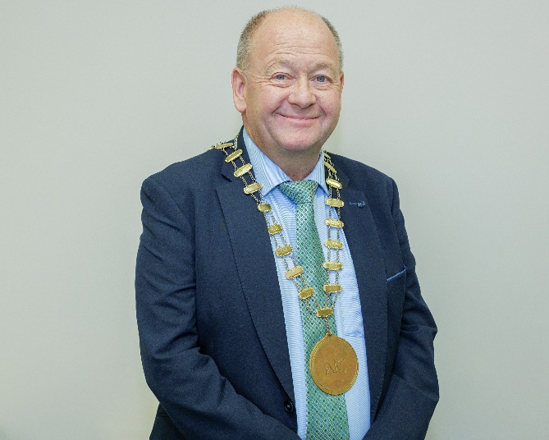 | Cllr. Gail Dunne is a member of Wicklow County Council, representing the Wicklow Town district and was elected President of the AILG at the Annual General Meeting which was held in Limerick on the 4th of October 2023.  (Cllr. Dunne will unfortunately be unable to attend the launch event – AILG Executive member Cllr. Pat Fitzpatrick is deputising on his behalf)

Cllr. Pat Fitzpatrick | AILG Executive Member (former AILG Preisdent)
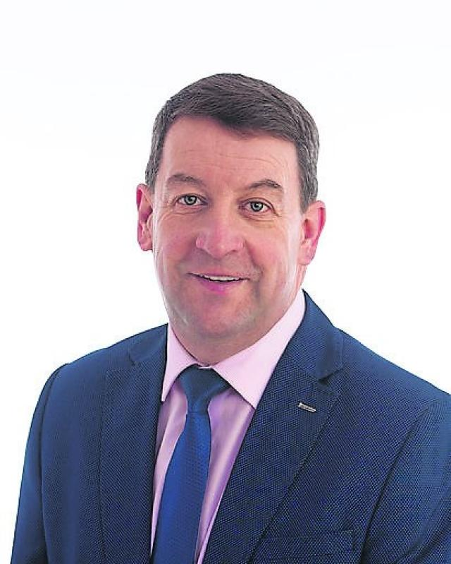 | Castlecomer Municipal District Councillor Pat Fitzpatrick is a member of Kilkenny County Council and is the former President of the Association of Irish Local Government (AILG), serving his term of office from 2022-2023.  Pat is deputising at the launch event on behalf of current AILG President Cllr. Gail Dunne who is unable to attend.

Mr. Tommy Moylan |  | AILG Director
 | 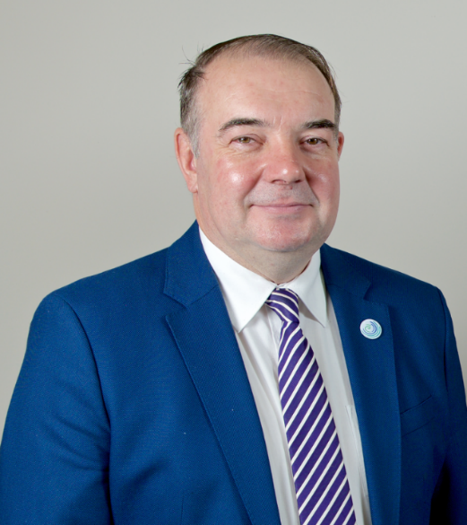 | Tommy is a qualified accountant by profession and has a wide range of experience in local government having served as a public representative for 15 years.  Tommy was a member of the working group for engagement with Local Authority Representative Associations working with the Department of Environment Community & Local Government on Local Government policy in relation to the Local Government Reform Act 2014. In July 2015, following a national recruitment process he was appointed co-director of the AILG.

Speakers at Launch of Research Report
Professor Eeva Leinonen | Maynooth University President
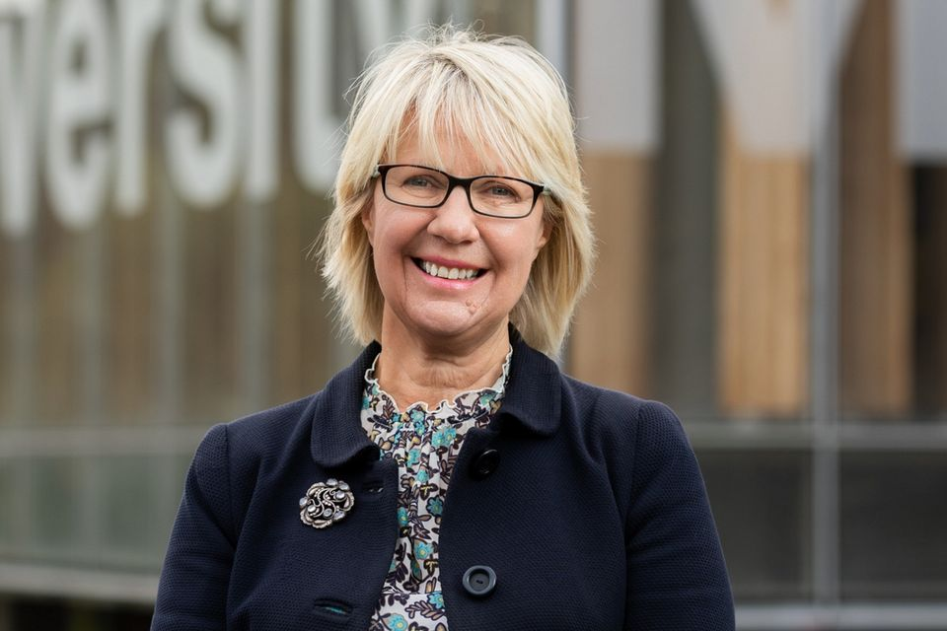 | Professor Eeva Leinonen joined Maynooth University as President in October 2021, after five years of service as Vice Chancellor and President at Murdoch University, Perth, Australia.  Professor Leinonen was born and raised in Finland, where she completed her schooling. As part of her education in Finland Professor Leinonen spent a year as an exchange student in Michigan, USA, prior to entering university in England, where she studied linguistics and psychology. She obtained a BSc (Hons) in Linguistics and Psychology (First Class) from Aston University, UK; MPhil in Text Linguistics from Exeter University, UK: PhD in Clinical Linguistics from De Montfort University, UK; Docent (Higher Doctorate) from her hometown university, University of Oulu, Finland; and DSc (Honoris Causa) from Aston University, UK.  Professor Leinonen’s academic research focuses on pragmatic language processing in children and young adults with autistic spectrum disorders. She collaborates with colleagues in Finland and Italy.

Daithí de Róiste | Lord Mayor of Dublin (Daithí de Róiste)
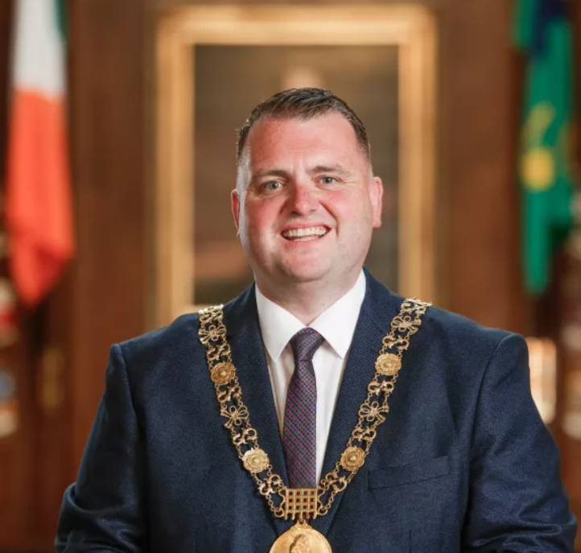  The Lord Mayor is addressed as “Lord Mayor of Dublin Daithí de Róiste” or “Lord Mayor Daithí de Róiste”. | Councillor Daithí de Róiste was elected the 355th Lord Mayor of Dublin at the Annual Meeting of Dublin City Council held on 26th June 2023 in the Council Chamber of City Hall. Councillor Claire O’Connor was elected the Deputy Lord Mayor.  Daithí was born and raised in Ballyfermot, Dublin. He is the son of Michael and Catherine Roche and he has one sister, Emma. He is married to Amy de Róiste since 2016. A member of Fianna Fáil, he was elected to Dublin City Council (DCC) in 2014 at the age of 26 and was subsequently re-elected in 2019, representing the Ballyfermot/Drimnagh local electoral area.  He is a member of DCC Strategic Policy Committees (SPC’s) on Finance and Planning and a member of the Citywide Joint Policing Committee since 2014. He is also a member of the budget consultative group of the Council. Councillor De Róiste graduated with a degree in History from University College Dublin and a Masters in Public Affairs from DIT (TUD). He has worked in marketing and communications for over a decade.

Maynooth Research Project Team

 | Ms. Caroline Creamer | Director of the International Centre for Local and Regional Development (ICLRD)  Project Team Member for the Research Report
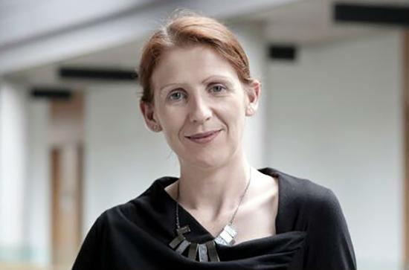 |  | Caroline is Director of the International Centre for Local and Regional Development (ICLRD) and a Research Fellow with the Maynooth University Social Sciences Institute and the Innovation Value Institute at Maynooth University. She is Facilitator of the All Ireland Smart Cities Forum, and ESPON Contact Point for Ireland. She has worked in a research and management capacity on a number of funded  projects and action research programmes – at various scales – over the past 20 years.  She has been actively involved in the co-design and delivery of capacity building training with Councils, and in the creation of learning networks for different sectoral interests. A qualified town planner, her research interests include spatial planning practice and policy, leadership in place-making and placeshaping, regional and local development and regeneration, collaborative and participative decision-making, and inter-territorial and crossborder development.

Dr. Brendan O’ Keefe | Senior Research Associate with ICLRD  Project Team Member for the Research Report
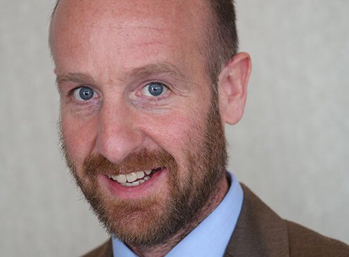 | Brendan operates an independent research consultancy. He is a senior research associate with the ICLRD and has worked with ICLRD colleagues on several projects and initiatives in both research and facilitation capacities over the past fifteen years.  Brendan is passionate about good governance and rural and community development. His main areas of expertise are social research, local development, community planning, evaluations, project management and organisational change.

Dr. Brid Quinn | Chair of the Independent Project Steering Group for the Research Report
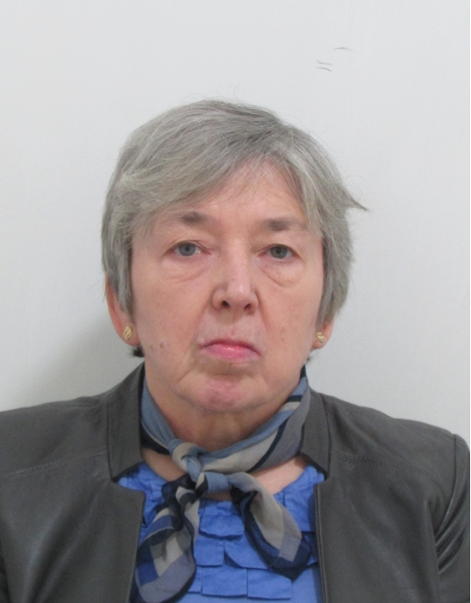 | Dr. Brid Quinn, Formerly University of  Limerick; Currently a member of the Group  of Independent Experts of the Congress of Local and Regional Authorities of Europe (CLRAE).  Dr. Bríd Quinn, B.Ed (NUI), MA & PhD (Limerick), Until her retirement in October 2018, Dr. Quinn was a Lecturer in Public Administration, specialising in local governance, EU regional and territorial policies, MLG and administrative reform. She has served as Course Director for the BA Public Administration, BA European Studies, MPA and MA/GD in Partnership Studies. She was co-convenor of the PSAI Specialist Group on Teaching and Learning until 2019.  Long involved in local and regional development activities and evaluation, she is a member of the Council of Europe's team of experts on local government. She is involved in EAPAA's accreditation team. She has carried out consultancy work in Ireland, Europe and Tanzania and participated in a range of EU research projects, being currently involved in the PROSEPS project.

Minister Darragh O’ Brien, TD. | Minister for Housing, Local Government and Heritage of Ireland
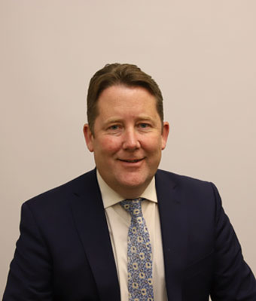 | Darragh O'Brien was appointed Minister for Housing, Local Government and Heritage in June 2020.  He is an elected TD for the constituency of Dublin-Fingal. Prior to his election to the 30th Dáil in 2007, Minister O’Brien worked mainly in Financial Services and was elected to Fingal County Council in 2004. He was elected to Seanad Éireann in 2011.  He has held various positions within the Oireachtas including Vice-Chairperson of the Public Accounts Committee, Member of the Oireachtas Committee on Justice, Equality, Defence and Law Reform, Leader of Fianna Fáil in the Seanad and Opposition Frontbench Spokesperson on Dublin, Foreign Affairs and Housing.

Minister Kieran O'Donnell, TD. | Minister of State at the Department of Housing, Local Government and Heritage with responsibility for Local Government and Planning
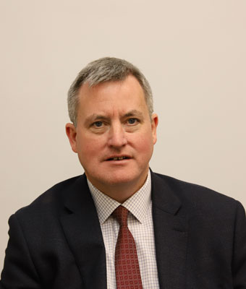 | Kieran O’Donnell TD is the Minister of State at the Department of Housing, Local Government and Heritage with responsibility for Local Government and Planning, appointed in December 2022.  He is the Fine Gael TD for Limerick City Constituency. First elected in May 2007, he was re-elected in 2011 and 2020.  He has served as:  Chairperson of the Oireachtas Transport and Communications Committee  Vice-Chairperson of the Public Accounts Committee (PAC) member of the Banking Inquiry member of the Oireachtas Finance and Budgetary Affairs Committees  spokesperson on Finance for Fine Gael.  He was elected to the Seanad in 2016. Prior to his entry into national politics, he was elected to Limerick County Council in 2004.  Minister O’Donnell is a Chartered Accountant, with many years of experience with his own practice and is a business studies degree graduate from the University of Limerick (UL).

